Hypermarket Sales Database System

Mini Project Report -Database Lab (DSE 2260)

Department of Data Science & Computer Applications



B. Tech Data Science

4th Semester – Batch: B1

Submitted By

|  |  |
| --- | --- |
| M.Prashanth Choudary | 210968053 |
| Vinayak Santhosh Kumar | 210968047 |
| Anirudh Derangula | 210968052 |
| Dishita Mohan | 210968054 |
| Suzen Firasta | 210968058 |

**Mentored By**

|  |  |
| --- | --- |
| Vinayak M | Archana H/ Dr. Natesh |
| Assistant Professor-Senior | Assistant Professor-Senior |
| DSCA, MIT | DSCA, MIT |



Date:

**CERTIFICATE**

This is to certify that the M.Prashanth Choudary (210968053), Vinayak Santhosh Kumar (210968047), Anirudh Derangula (210968052), Dishita Mohan (210968054), Suzen Firasta (210968058), have successfully executed a mini project titled “Hypermarket Sales Database” rightly brining fore the competencies and skill sets they have gained during the course- Database Lab (DSE 2262 & DSE), thereby resulting in the culmination of this project.

|  |  |
| --- | --- |
| **Vinayak M** | **Archana H / Dr. Natesh** |
| **Assistant Professor-Senior** | **Assistant Professor-Senior** |
| **DSCA, MIT** | **DSCA, MIT** |

**ABSTRACT**

In today's business world, hypermarkets need to have an efficient and effective sales database management system to handle the large volume of sales and inventory data they generate. Hypermarket sales databases provide a centralized and structured way to capture, store, manage, and analyse this data, which can lead to improved business performance and increased revenue. Therefore, the objective of this project work is to develop a hypermarket sales database management system that can help improve the efficiency and profitability of the hypermarket.

The results of this project work show that the hypermarket sales database management system is capable of handling large volumes of sales and inventory data, providing real-time insights into business performance. The system also helps the hypermarket streamline inventory management, reduce stockouts and overstocking, improve customer satisfaction, and increase sales revenue. By providing real-time insights into sales and inventory data, the system can help hypermarkets make data-driven decisions that can drive growth and profitability.

Overall, the hypermarket sales database management system developed in this project work is a valuable tool for any hypermarket looking to improve its business performance.

Contents

**1. Introduction 1**

**2. Synopsis 2**

**2.1 Proposed System 2**

**2.2 Objectives 2**

**3. Data Requirements 3**

**4. Functional Requirements 3**

**5. Detailed Design 7**

**5.1 ER Diagram 9**

**5.2 Schema Diagram 10**

**5.3 Data Dictionary 12**

**5.4 Relational Model Implementation 13**

**5.5 Queries 14**

**5.7 Triggers ..**

**5.8 Stored Procedures ..**

**5.9 Stored Functions**

**6. Implementation Functional Requirements**

**7. Result**

**8. Conclusion and Future Work 20**

Chapter 1

Introduction

The Sales Management System for Hypermarkets allows users to record sales transactions, generate invoices, and track payments. It also enables the management of inventory levels by providing real-time updates on stock levels, allowing users to make informed decisions about restocking and ordering products. The system also includes features such as customer management, employee management, and reporting, making it a comprehensive solution for hypermarkets.

The project is designed to be flexible and customizable, allowing hypermarket owners to tailor the system to their specific needs. It is also designed to be user-friendly, with an intuitive interface that requires minimal training for users to get started. Overall, the Sales Management System for Hypermarkets is a powerful tool for hypermarket owners to manage their sales and inventory operations efficiently, helping them to improve their bottom line and increase customer satisfaction.

One of the key benefits of the Sales Management System for Hypermarkets is the ability to track sales and inventory levels in real-time. This means that hypermarket owners can monitor their sales performance and inventory levels in real-time, giving them a competitive edge in the market. The system also allows for the creation of custom reports, providing valuable insights into the hypermarket's performance and allowing for informed decision-making.

In addition to sales and inventory management, the Sales Management System for Hypermarkets also includes customer management features, allowing hypermarket owners to create and maintain customer profiles, track customer purchases and preferences, and create targeted marketing campaigns. Employee management features are also included, allowing hypermarket owners to track employee performance and manage payroll.

Overall, the Sales Management System for Hypermarkets is a comprehensive solution for hypermarket owners looking to streamline their sales and inventory management processes. It provides an easy-to-use interface, powerful reporting capabilities, and can be customized to meet the specific needs of any hypermarket. With this system in place, hypermarket owners can improve their bottom line, increase customer satisfaction, and stay ahead of the competition.

Chapter 2

Synopsis

**2.1 Proposed System**

The hypermarket sales database management system offers several features to manage inventory, sales and promotions, customer behaviour and more. It provides a structured and organized manner to store data and allows hypermarkets to access real-time data on sales performance, inventory levels, and customer behaviour.

The database is organized into several tables, some of them include:

1. Products Table: This table stores information about the products offered by the hypermarket, such as product ID, name, description, price, and supplier information.
2. Sales Table: This table stores information about each sale transaction, such as the date and time of the transaction, the product ID, the quantity sold, and the total price.
3. Inventory Table: This table stores information about inventory levels, such as the product ID, quantity in stock, and location within the store.
4. Customer Table: This table stores information about customers, such as their name, contact information, and purchase history.
5. Promotions Table: This table stores information about promotions and discounts offered by the hypermarket, such as the promotion ID, the product ID, the discount percentage, and the start and end dates of the promotion.
6. Suppliers Table: This table stores information about the hypermarket's suppliers, such as their name, contact information, and product offerings.

The hypermarket sales database management system can help hypermarkets improve operational efficiency, increase sales revenue, and enhance customer satisfaction. With its various features and tables, it provides hypermarkets with real-time insights into their business performance, enabling them to make data-driven decisions that can drive growth and profitability.

**2.2 Objectives**

Main objectives of this database are the following:

* Set revenue target to be achieved within a certain period and track progress using sales data generated by the system.
* Reduce stockouts and overstocking.
* Calculating the total revenue for the month.
* Set a target for customer satisfaction ratings and track feedback received through the system.

Chapter 3

**Data Requirements**

Ensures that data produced and consumed satisfies business objectives, is understood by all relevant stakeholders, and meets the needs of the business processes that create and use the data.]

**3.1** **Purpose, scope and overview**

The Data Requirement Document (DRD) is a central document of the project, in which all information relating to data is gathered for agreement by the key stakeholders and then for guidance and information for those involved in the project. The data requirements are listed in the following sections and describe the essential data requirements for the *Banking* application.

The application requires data describing the Customers, branches, accounts and data managing different operations such as deposit, withdrawal operations. Following are main entities about which data requirement is to be documented.

1. Customers
2. Bank Branches
3. Accounts of each customer
4. Data relevant to the transactions done by customers

**3.2 Requirements**

**3.2.1 Orders**

|  |  |  |
| --- | --- | --- |
| Following Data related to bank customer need to be captured. | | |
| **Data Name** | **Description** | **Example** |
| ORD_ID | An order_id attribute in a database management system (DBMS) is typically used to uniquely identify an order. It is often used as a primary key in an orders table and as a foreign key in other tables that need to reference information about a specific order. This attribute can be used to track the progress of orders, to support business processes such as order fulfillment or customer service, and to generate reports or statistics about orders. | O101 |
| D_ID | A 5-digit numeric value representing the distributor’s ID | 56231 |
| STORE_ID | store_ID is a common column name used in database tables to uniquely identify a store or location. It is typically used as a primary key in a store order table and as a foreign key in other tables that need to reference information about a specific store. | S101 |
| SHIP_MODE | SHIP_MODE is a common column name used in database tables to store information about the shipping method or mode for an order or shipment. It could contain values such as “Ground”, “Air”, “Express”, etc. | Air |
| SHIP_STAT | A SHIP_STAT attribute in a database management system (DBMS) is typically used to store information about the current status of a shipment. It could contain values such as “In Transit”, “Delivered”, “Delayed”, etc. This attribute can be used to track the progress of shipments and to provide updates to customers or other stakeholders. | Delivered |
| ORD_DATE | An ORD_DATE attribute in a database management system (DBMS) is typically used to store the date on which an order was placed. This attribute can be used to track the progress of orders, to generate reports or statistics about order volume over time, and to support other business processes such as inventory management or forecasting. | 12/12/2012 |
| PMY_STAT | An alphanumeric value of minimum 8 characters containing at least one capital, number, special character | Abc$ef29 |

**3.2.2 Distributor**

|  |  |  |
| --- | --- | --- |
| Following Data related to different distributors needs to be captured | | |
| **Data Name** | **Description** | **Example** |
| D_ID | A 5-digit numeric value representing the distributor’s ID | 12345 |
| D_NAME | Name of distributor | Thomas |
| D_PASS | Pass of distributor |  |
| D_TYPE | Type of product supplied by the distributor | Electrical |
| D_LOC | Location of distributor | Mumbai |

**3.2.3 Sales**

|  |  |  |
| --- | --- | --- |
| Following Data is used to capture sales details including date and cost of each sale. | | |
| **Data Name** | **Description** | **Example** |
| SALES_ID | A 3-digit numeric value representing a unique ID for each sale | 412 |
| S_Date | Date of Sale | 25/11/2022 |
| S_Cost | Cost of Sale | 64000 |
| S_ID | A 3-digit numeric value representing a unique ID for stock | 223 |

**3.2.4 Stock**

|  |  |  |
| --- | --- | --- |
| Following Data is used to capture stock details including quantity and type of stock. | | |
| **Data Name** | **Description** | **Example** |
| S_ID | A 3-digit numeric value representing a unique ID for stock | 111 |
| QUANT | Quantity of stock | 250 |
| CRY | Alphabet value to identify the category of stocks | Electronics |
| S_CRY | Alphabet value to identify the sub-category of stocks | Headphones |

**3.2.5 Store**

|  |  |  |
| --- | --- | --- |
| Following Data is used to capture store details. | | |
| **Data Name** | **Description** | **Example** |
| S_ID | A 3-digit numeric value representing a unique ID for stock | 111 |
| S_STATE | Alphabetic value to specify the state | Karnataka |
| S_PCODE | A 6-digit numeric value representing pin code of location | 576104 |
| S_BRANCHNAME | Alphabetic value to specify the store branch name | Hi-Tech City |
| S_CITY | Alphabetic value to specify the city | Bangalore |
| S_PASS |  |  |
| S_REGION | Alphabetic value to specify the region (North, South, East, West) of the State | East Karnataka |

Chapter 4

**Functional Requirements**

What is a Functional Requirement?

A Functional Requirement (FR) is a description of the service that the software must offer. It describes a software system or its component. A function is nothing but inputs to the software system, its behaviour, and outputs. It can be a calculation, data manipulation, business process, user interaction, or any other specific functionality which defines what function a system is likely to perform. ]

Briefly write overview of functionalities provided by the application in terms of different modules.

**4.1 User Registering/Login module**

Two lines about module briefly and it supports functionalities- New user registration, Login, Forgot password

**4.1.1 New User Registration**

The user must be able to create user id and password by supplying appropriate details.

|  |  |
| --- | --- |
| INPUT | New username, Password, phone |
| Processing | The system must check availability of entered user name.  Password must follow criteria- minimum 9 char, at least one capital, one number and one special character.  Check for validity of phone number by prompting to enter OTP |
| OUTPUT | User created Successfully message / highlight the information entered which is wrong and allow to renter. |

**4.1.2 Login**

The existing user must be able to login upon entering proper user name and password.

|  |  |
| --- | --- |
| INPUT | username, Password |
| Processing | Check the user name and password against information stored in data storage |
| OUTPUT | If user entered correct user name & Password  Login successful and open main application menu  Else  Display Login not successful, retry logging in |

**4.1.3 Forgot password**

If existing user name is not bale to login, forgot password can be used to reset password.

|  |  |
| --- | --- |
| INPUT | Prompt user to enter username, Phone |
| Processing | If username and corresponding phone exist in the data storage  Send OTP to Phone.  Prompt the user to enter OTP  If OTP matching  Prompt user to change password according to criteria.  Else  OTP not matching.  Else  User name and corresponding Phone not existing in the storage |
| OUTPUT | Password successfully changed / User name, phone not matching |

**4.1.3 Money Withdrawal**

After validating user, user selects for withdrawal operations by inputting amount.

|  |  |
| --- | --- |
| INPUT | Prompt user to enter Amount |
| Processing | If Balance amount after withdrawing amount > minimum balance then  Allow withdrawal and update Balance  else  Cancel withdrawal & Show message “No Enough Fund” |
| OUTPUT | Balance updated / No Enough Fund |

Chapter 5

**Detailed Design**

**5.1 ER Diagram**

An ER diagram is a graphical representation of entities and their relationships to each other in a database. It typically includes entities, attributes, and relationships, and is used to design and communicate the structure of a database.

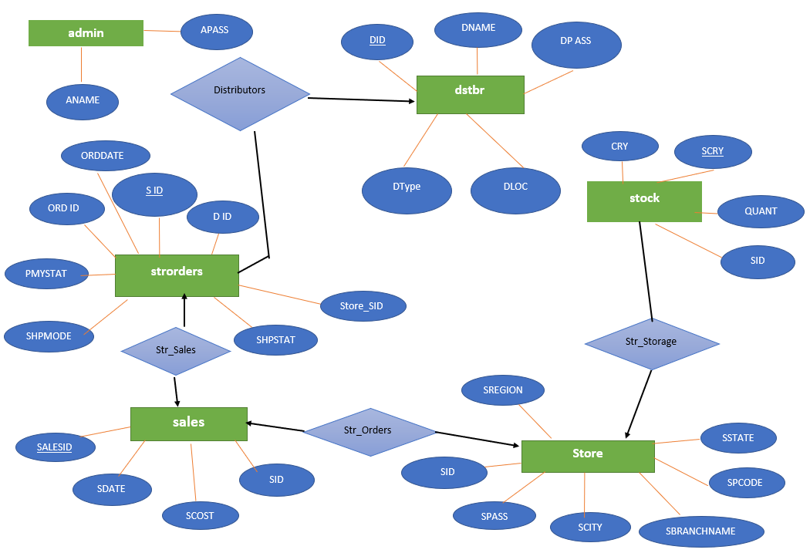

The following ER diagram includes entity **DSTBR** and **STR_ORDERS** related to each other through a **one-to-many** relationship **Distributors.**

Entity **STR_ORDERS** and **SALES** related to each other through **one-to-one** relationship **Str_Sales.**

Entity **STORE** and **SALES** related to each other through **one-to-one** relationship **Str_Orders.**

Entity **STORE** and **STOCK** related to each other through **one-to-many** relationship **Str_Storage.**

**5.2 Schema Diagram**

**STR_ORDERS (**ORD_ID, ORD_DATE, SHIP_STAT,PMY_STAT,SHIP_MODE,S_ID,D_ID)

ORD_ID References DSTBR(D_ID)

**SALES (**SALES_ID, S_Date, S_Cost,S_ID)

**STOCK (**S_ID, S_CRY, QUANT,CRY)

S_ID References STORE

**DSTBR** (D_ID , D_NAME , D_PASS, D_TYPE , D_LOC)

**STORE (**S_ID, S_STATE,S_PCODE,S_BRANCHNAME,S_CITY,S_PASS,S_REGION)

**ADMIN (**A_NAME,A_PASS)

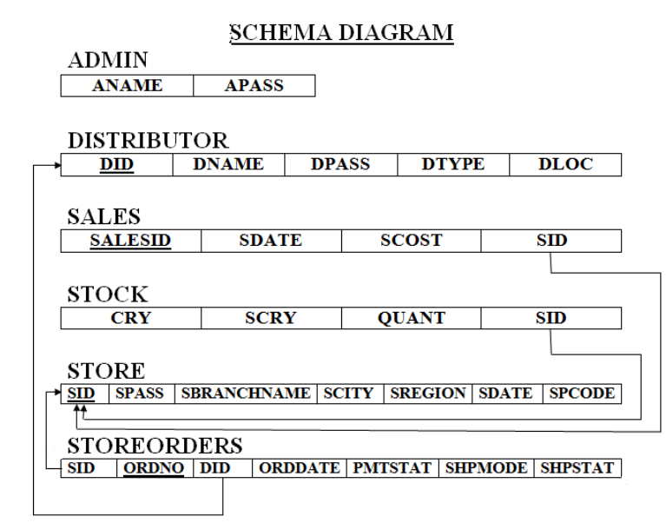

**5.3 Data Dictionary**

**ORDERS**

|  |  |  |  |
| --- | --- | --- | --- |
| Column | Data type (size) | Constraint | Constraint Name |
| ord_id | Number(10) | Primary Key | PK_STR_ORDERS |
| ord_date | Date | Not Null | NOT_NULL_ORD_DATE |
| ship_stat | Varchar2(20) | Not Null | NOT_NULL_SHIP_STAT |
| pmy_stat | Varchar2(20) | Not Null | NOT_NULL_PMY_STAT |
| ship_mode | Varchar2(20) | Not Null | NOT_NULL_SHIP_MODE |
| s_id | Number(10) | Foreign Key to STORE(s_id) | FK_STR_ORDERS_STORE |
| d_id | Number(10) | Foreign Key to DSTBR(d_id) | FK_STR_ORDERS_DSTBR |

**SALES**

|  |  |  |  |
| --- | --- | --- | --- |
| Column | Data type (size) | Constraint | Constraint Name |
| sales_id | Number(10) | Primary Key | PK_SALES |
| s_date | Date | Not Null | NOT_NULL_S_DATE |
| s_cost | Number(10,2) | Not Null | NOT_NULL_S_COST |
| s_id | Number(10) | >1000 | FK_SALES_STORE |

**STOCK**

|  |  |  |  |
| --- | --- | --- | --- |
| Column | Data type (size) | Constraint | Constraint Name |
| s_id | Number(10) | Primary Key | PK_STOCK |
| s_cry | Varchar2(20) | Not Null | NOT_NULL_S_CRY |
| quant | Number (5) | Not Null | NOT_NULL_QUANT |
| cry | Varchar2(20) | Not Null | NOT_NULL_CRY |

**DISTRIBUTOR**

|  |  |  |  |
| --- | --- | --- | --- |
| Column | Data type (size) | Constraint | Constraint Name |
| d_id | Number(10) | Primary Key | PK_DSTBR |
| d_name | Varchar2(20) | Not Null | NOT_NULL_D_NAME |
| d_pass | Number (5) | Not Null | NOT_NULL_D_TYPE |
| d_type | Varchar2(20) | Not Null | NOT_NULL_D_TYPE |
| d_loc | Number(10) | Not Null | NOT_NULL_D_LOC |

**STORE**

|  |  |  |  |
| --- | --- | --- | --- |
| Column | Data type (size) | Constraint | Constraint Name |
| s_id | Number(10) | Primary Key | PK_STORE |
| s_state | Varchar2(20) | Not Null | NOT_NULL_S_STATE |
| s_pcode | Number (6) | Not Null | NOT_NULL_S_PCODE |
| s_branchname | Varchar2(20) | Not Null | NOT_NULL_S_BRANCHNAME |
| s_city | Varchar2(20) | Not Null | NOT_NULL_CITY |
| s_region | Varchar2(20) | Not Null | NOT_NULL_REGION |

**ADMIN**

|  |  |  |  |
| --- | --- | --- | --- |
| Column | Data type (size) | Constraint | Constraint Name |
| a_ name | Varchar2(20) | Not Null | NOT_NULL_A_NAME |
| a_pass | Varchar2(15) | Not Null | NOT_NULL_A_PASS |

**5.4 Relational Model Implementation**

We use DDL Commands to define the structure for the Relational Model.

Creating, altering and inserting into table **ADMIN.**

CREATE TABLE admin (

ANAME varchar(20) CONSTRAINT NOT_NULL_A_NAME NOT NULL,

APASS varchar(20) CONSTRAINT NOT_NULL_A_PASS NOT NULL

);

**INSERTION COMMANDS:**

INSERT INTO admin (ANAME, APASS) VALUES ('555', 'admin');

**ALTER TABLE COMMANDS:**

ALTER TABLE admin ADD CONSTRAINT pr_key PRIMARY KEY (APASS);

Creating, altering and inserting into table **DSTBR.**

CREATE TABLE dstbr (

DID NUMBER(11) CONSTRAINT PK_DSTBR PRIMARY KEY,

DNAME varchar(20) CONSTRAINT NOT_NULL_D_NAME NOT NULL,

DPASS varchar(20) CONSTRAINT NOT_NULL_D_PASS NOT NULL,

DTYPE varchar(20) CONSTRAINT NOT_NULL_D_TYPE NOT NULL,

DLOC varchar(30) CONSTRAINT NOT_NULL_D_LOC NOT NULL

);

**ALTER TABLE COMMANDS:**

ALTER TABLE dstbr ADD FOREIGN KEY (APASS) REFERENCES admin(APASS);

ALTER TABLE dstbr ADD PRIMARY KEY (DID);

**INSERTION COMMANDS:**

INSERT INTO dstbr VALUES (1000, 'Fritolay', 'admin', 'Electrical', 'Delhi');

INSERT INTO dstbr VALUES (1001, 'Pepsico', 'admin', 'CoolDrinks', 'Hyd');

Creating, altering and inserting into table **SALES.**

CREATE TABLE sales (

salesID NUMBER CONSTRAINT PK_SALES PRIMARY KEY,

sdate VARCHAR2(20) CONSTRAINT NOT_NULL_S_DATE NOT NULL,

scost NUMBER CONSTRAINT NOT_NULL_S_COST NOT NULL,

sid NUMBER CONSTRAINT FK_SALES_STOCK FOREIGN KEY

);

**INSERTION COMMANDS:**

INSERT INTO sales VALUES (222, '22/11/2018', 40079, 100);

INSERT INTO sales VALUES (227, '11/11/2018', 59879, 100);

INSERT INTO sales VALUES (228, '27/11/2018', 60000, 100);

INSERT INTO sales VALUES (229, '25/11/2018', 70000, 100);

**ALTER TABLE COMMANDS:**

ALTER TABLE sales ADD PRIMARY KEY (SALESID);

Creating, altering and inserting into table **STOCK.**

CREATE TABLE stock (

SID NUMBER CONSTRAINT PK_STOCK PRIMARY KEY,

CRY varchar(20) NOT_NULL_CRY NOT NULL,

SCRY varchar(20) NOT_NULL_S_CRY NOT NULL,

QUANT NUMBER NOT_NULL_QUANT NOT NULL,

) ;

**INSERTION COMMANDS:**

INSERT INTO stock VALUES ('Electronics', 'Mobiles', 30, 100);

**ALTER TABLE COMMANDS:**

ALTER TABLE stock ADD CONSTRAINT stock_ibfk_1 FOREIGN KEY (SID) REFERENCES store (SID) ON DELETE CASCADE;

Creating, altering and inserting into table **STORE.**

CREATE TABLE store (

SID NUMBER CONSTRAINT PK_STORE PRIMARY KEY,

SPASS varchar(20) NOT_NULL_S_PASS NOT NULL,

SBRANCHNAME varchar(20) NOT_NULL_S_BRANCHNAME NOT NULL,

SCITY varchar(20) NOT_NULL_S_CITY NOT NULL,

SREGION varchar(20) NOT_NULL_S_REGION NOT NULL,

SSTATE varchar(20) NOT_NULL_S_STATE NOT NULL,

SPCODE NUMBER NOT_NULL_S_PCODE NOT NULL

);

**INSERTION COMMANDS:**

INSERT INTO store VALUES(100, 'admin', 'Branch2', 'zhb', 'south', 'Tela', 222);

INSERT INTO store VALUES (101, 'admin', 'Silk Point', 'Bidar', 'North Karnataka', 'Karnataka', 585401);

Creating, altering and inserting into table **STRORDERS.**

CREATE TABLE strorders (

ORDID NUMBER CONSTRAINT PK_STR_ORDERS,

SID NUMBER NOT_NULL_S_ID NOT NULL,

DID NUMBER NOT_NULL_S_ID NOT NULL,

ORDDATE DATE NOT_NULL_ORD_DATE NOT NULL,

PMYSTAT varchar(20) NOT_NULL_PMY_STAT NOT NULL,

SHIPMODE varchar(20) NOT_NULL_SHIP_MODE NOT NULL,

SHIPSTAT varchar(20) NOT_NULL_SHIP_STAT NOT NULL

);

**INSERTION COMMANDS:**

INSERT INTO strorders VALUES (100, 500, 1000, DATE'2018-11-20', 'PENDING', 'Premium', 'Delivered');

INSERT INTO strorders VALUES (0, 501, 1000, DATE '2018-11-20', 'PAID', 'Normal', 'PENDING');

INSERT INTO strorders VALUES (100, 502, 1000, DATE'2018-11-20', 'PAID', 'Premium', 'Delivered');

INSERT INTO strorders VALUES (100, 503, 1000, DATE '2018-11-20', 'PAID', 'Normal', 'PENDING');

INSERT INTO strorders VALUES (100, 504, 1000, DATE '2018-11-20', 'PENDING', 'Normal', 'PENDING');

INSERT INTO strorders VALUES (100, 505, 1000, DATE '2018-11-20', 'PENDING', 'Normal', 'PENDING');

INSERT INTO strorders VALUES (100, 506, 1000, DATE '2018-11-21', 'PENDING', 'Normal', 'PENDING');

INSERT INTO strorders VALUES (100, 507, 1000, DATE '2018-11-22', 'PENDING', 'Normal', 'PENDING');

INSERT INTO strorders VALUES (100, 508, 1000, DATE '2018-11-30', 'PENDING', 'Normal', 'PENDING');

**ALTER TABLE COMMANDS:**

ALTER TABLE strorders ADD CONSTRAINT strorders_pk PRIMARY KEY (ORDID);

CREATE INDEX strorders_did_idx ON strorders (DID);

ALTER TABLE strorders ADD CONSTRAINT strorders_ibfk_1 FOREIGN KEY (DID) REFERENCES dstbr (DID) ON DELETE CASCADE;

**5.5 Queries**

List of queries used to retrieve data

**5.5.1** SQL query to selects all columns from the "strorders" table where the SID (store ID) is equal to 100 and the order date (ORDDATE) is between November 21st, 2018 and November 30th, 2018.

SELECT *

FROM strorders

WHERE SID = 100

AND ORDDATE BETWEEN TO_DATE('21-NOV-2018', 'DD-MON-YYYY') AND TO_DATE('30-NOV-2018', 'DD-MON-YYYY');

**OUTPUT:**

SID ORDID DID ORDDATE PMYSTAT

---------- ---------- ---------- --------- --------------------

SHPMODE SHPSTAT

-------------------- --------------------

100 506 1000 21-NOV-18 PENDING

Normal PENDING

100 507 1000 22-NOV-18 PENDING

Normal PENDING

100 508 1000 30-NOV-18 PENDING

Normal          PENDING

**5.5.2** This is a SQL query that retrieves the total sales cost for each store in the "sales" table.

SELECT s.sid, SUM(s.scost) AS total_sales_cost

FROM sales s

GROUP BY s.sid

**OUTPUT:**

SID TOTAL_SALES_COST

---------- ----------------

100          229958

…..

**5.6 Triggers**

List of triggers used to retrieve data

**5.6.1** This is a SQL trigger that prevents deletion of a record in the "store" table if there are any orders associated with it in the "strorders" table.

CREATE OR REPLACE TRIGGER prevent_store_deletion_trigger

BEFORE DELETE ON store

FOR EACH ROW

DECLARE

v_count NUMBER;

BEGIN

SELECT COUNT(*) INTO v_count FROM strorders WHERE sid = :OLD.sid;

IF v_count > 0 THEN

RAISE_APPLICATION_ERROR(-20001, 'Cannot delete store because there are still orders associated with it.');

END IF;

END;

/

**OUTPUT:**

SQL> DELETE FROM store WHERE sid = 100;

DELETE FROM store WHERE sid = 100

*

ERROR at line 1:

ORA-20001: Cannot delete store because there are still orders associated with

it.

ORA-06512: at "SCOTT.PREVENT_STORE_DELETION_TRIGGER", line 6

ORA-04088: error during execution of trigger

'SCOTT.PREVENT_STORE_DELETION_TRIGGER'

**5.6.2** This is a SQL trigger that prevents deletion of a record in the "store" table if there are any orders associated with it in the "strorders" table.

CREATE OR REPLACE TRIGGER prevent_sales_update_trigger

BEFORE UPDATE OF scost ON sales

FOR EACH ROW

BEGIN

IF :NEW.scost < :OLD.scost THEN

RAISE_APPLICATION_ERROR(-20001, 'Cannot update sales cost to a lower value.');

END IF;

  END;

  /

**OUTPUT:**

UPDATE sales SET scost = 40100 WHERE salesid = 222;

1 row updated;

UPDATE sales SET scost = 400 WHERE salesid = 222

ERROR at line 1:

ORA-20001: Cannot update sales cost to a lower value.

ORA-06512: at "SCOTT.PREVENT_SALES_UPDATE_TRIGGER", line 3

ORA-04088: error during execution of trigger

'SCOTT.PREVENT_SALES_UPDATE_TRIGGER'

**….**

**5.7 Stored Procedures**

List of Procedures used to retrieve data

**5.7.1** This is a SQL procedure that creates a new record in the "admin" table. The procedure takes two parameters: "aname_in" of type admin.aname%TYPE and "apass_in" of type admin.apass%TYPE. These parameters correspond to the "aname" and "apass" columns in the "admin" table.

CREATE OR REPLACE PROCEDURE insert_admin (aname_in IN admin.aname%TYPE, apass_in IN admin.apass%TYPE)

AS

BEGIN

INSERT INTO admin (aname, apass) VALUES (aname_in, apass_in);

COMMIT;

END;

/

**OUTPUT:**

SQL> BEGIN

2 insert_admin('John Doe', 'password123');

3 END;

4 /

PL/SQL procedure successfully completed.

SQL> select * from admin;

ANAME APASS

-------------------- --------------------

555 admin

John password

John Doe      password123

**5.7.2** This is a SQL procedure that updates the stock quantity of a particular item in the "stock" table. The procedure takes three parameters: "cry_in" of type stock.cry%TYPE, "scry_in" of type stock.scry%TYPE, and "quant_in" of type stock.quant%TYPE. These parameters correspond to the "cry", "scry", and "quant" columns in the "stock" table.

CREATE OR REPLACE PROCEDURE update_stock_quantity (cry_in IN stock.cry%TYPE, scry_in IN stock.scry%TYPE, quant_in IN stock.quant%TYPE)

AS

BEGIN

UPDATE stock SET quant = quant_in WHERE cry = cry_in AND scry = scry_in;

COMMIT;

END;

/

**OUTPUT:**

BEGIN

update_stock_quantity('Electronics', 'Mobiles', 50);

END;

CRY SCRY QUANT SID

-------------------- -------------------- ---------- ----------

Electronics Mobiles    50        100

**5.7.3** This is a SQL procedure that updates the stock quantity of a particular item in the "stock" table. The procedure takes three parameters: "cry_in" of type stock.cry%TYPE, "scry_in" of type stock.scry%TYPE, and "quant_in" of type stock.quant%TYPE. These parameters correspond to the "cry", "scry", and "quant" columns in the "stock" table.

CREATE OR REPLACE PROCEDURE get_total_sales(sid IN NUMBER, total_sales OUT NUMBER)

IS

BEGIN

SELECT SUM(SCOST) INTO total_sales FROM sales WHERE SID = sid;

END;

/

**USAGE:**

DECLARE

v_sid NUMBER := 1; -- replace 1 with the desired sid value

v_total_sales NUMBER;

BEGIN

get_total_sales(v_sid, v_total_sales);

DBMS_OUTPUT.PUT_LINE('Total sales: ' || v_total_sales);

END;

/

**OUTPUT:**

Total sales: 229958

**6. Functional Requirement Implementation**

**6.1**. SQL Query to implement ‘PREVENT_STORE_DELETION_TRIGGER’ trigger.

SQL> DELETE FROM store WHERE sid = 100;

DELETE FROM store WHERE sid = 100

**OUTPUT:**

ERROR at line 1:

ORA-20001: Cannot delete store because there are still orders associated with

it.

ORA-06512: at "SCOTT.PREVENT_STORE_DELETION_TRIGGER", line 6

ORA-04088: error during execution of trigger

'SCOTT.PREVENT_STORE_DELETION_TRIGGER'

**6.2**. SQL Query to implement ‘PREVENT_SALES_UPDATE_TRIGGER’ trigger.

UPDATE sales SET scost = 40100 WHERE salesid = 222;

1 row updated;

UPDATE sales SET scost = 400 WHERE salesid = 222

ERROR at line 1:

ORA-20001: Cannot update sales cost to a lower value.

ORA-06512: at "SCOTT.PREVENT_SALES_UPDATE_TRIGGER", line 3

ORA-04088: error during execution of trigger

'SCOTT.PREVENT_SALES_UPDATE_TRIGGER'

* 1. SQL Query to implement ‘ **insert_admin ’** Procedure.

BEGIN

insert_admin('John Doe', 'password123');

END;

/

**OUTPUT:**

PL/SQL procedure successfully completed.

SQL> select * from admin;

ANAME APASS

-------------------- --------------------

555 admin

John password

John Doe      password123

* 1. SQL Query to implement ‘ **update_stock_quantity’** Procedure.

BEGIN

update_stock_quantity('Electronics', 'Mobiles', 50);

END;

**OUTPUT:**

CRY SCRY QUANT SID

-------------------- -------------------- ---------- ----------

Electronics Mobiles    50        100

* 1. SQL Query to implement ‘ **get_total_sales ‘** Procedure.

DECLARE

v_sid NUMBER := 1; -- replace 1 with the desired sid value

v_total_sales NUMBER;

BEGIN

get_total_sales(v_sid, v_total_sales);

DBMS_OUTPUT.PUT_LINE('Total sales: ' || v_total_sales);

END;

/

**OUTPUT:**

Total sales: 229958

**7. Software Requirements**

Visual Studio Code (Front- end)

SQL*Plus* (Back-end)

**8. Result**

**MAIN PAGE:**

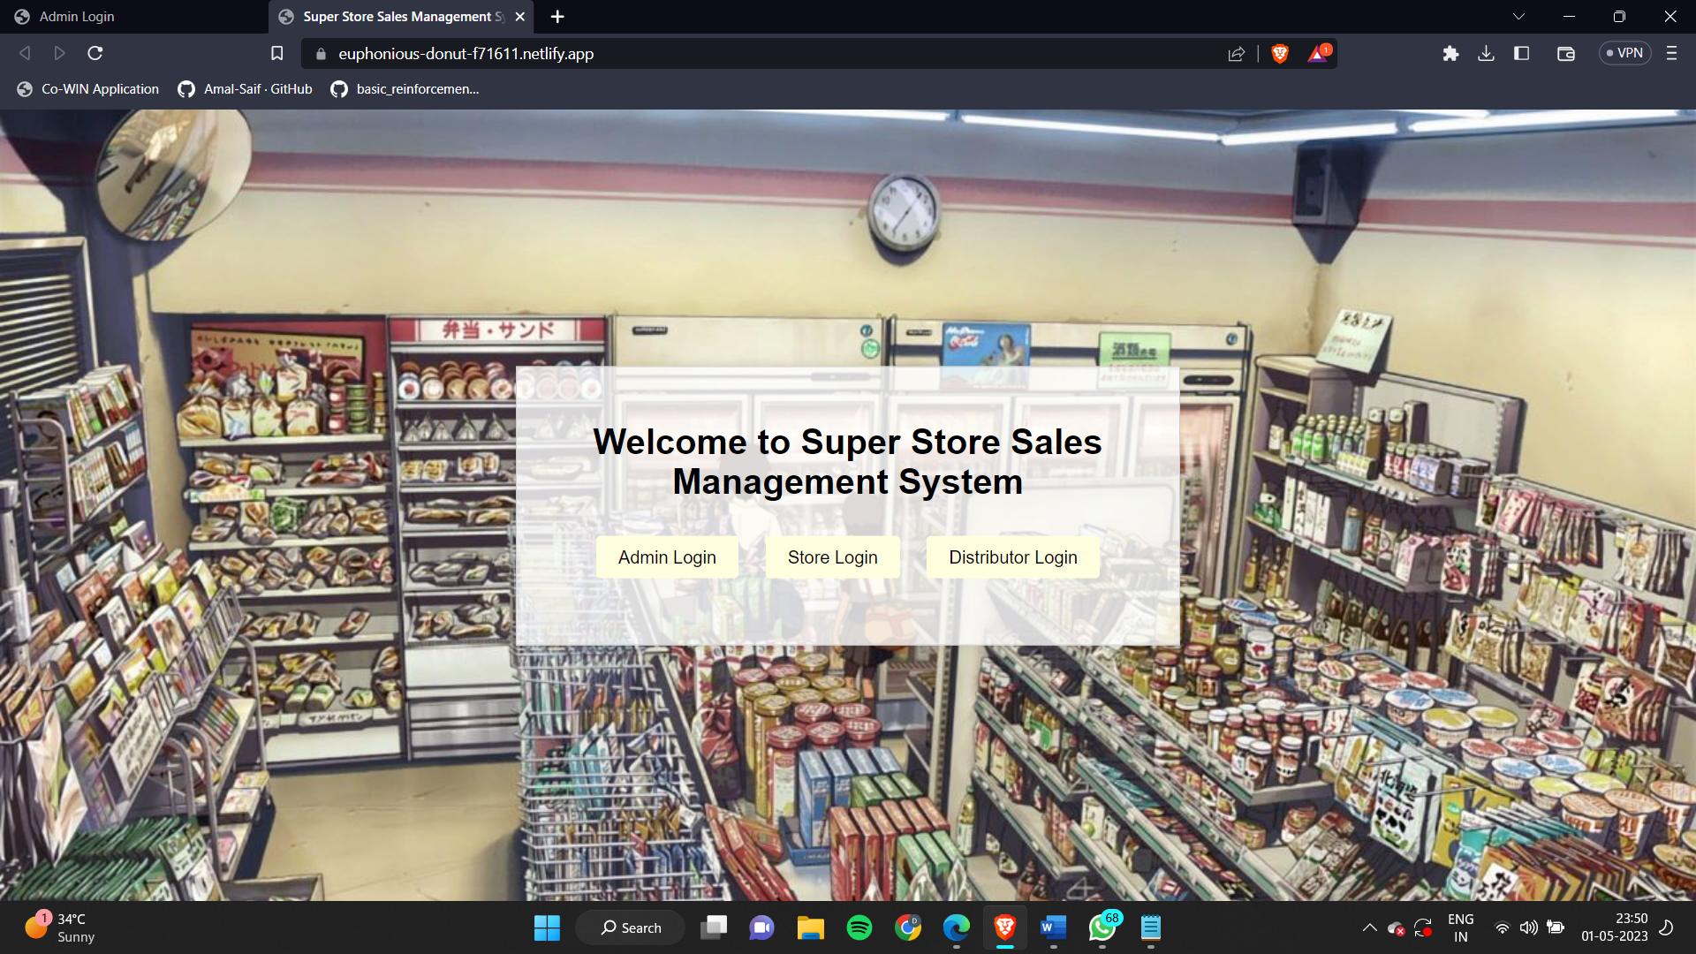

**ADMIN LOGIN PAGE:**

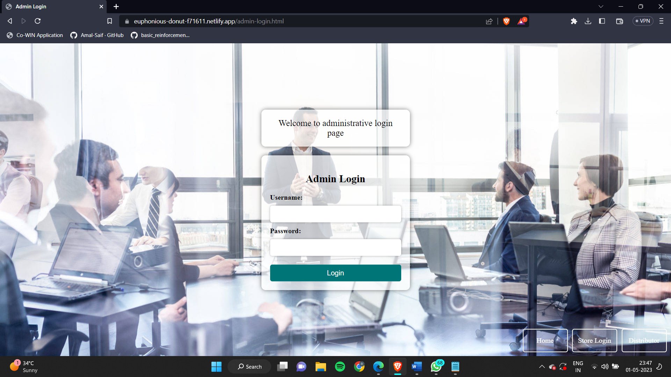

**STORE LOGIN PAGE:**

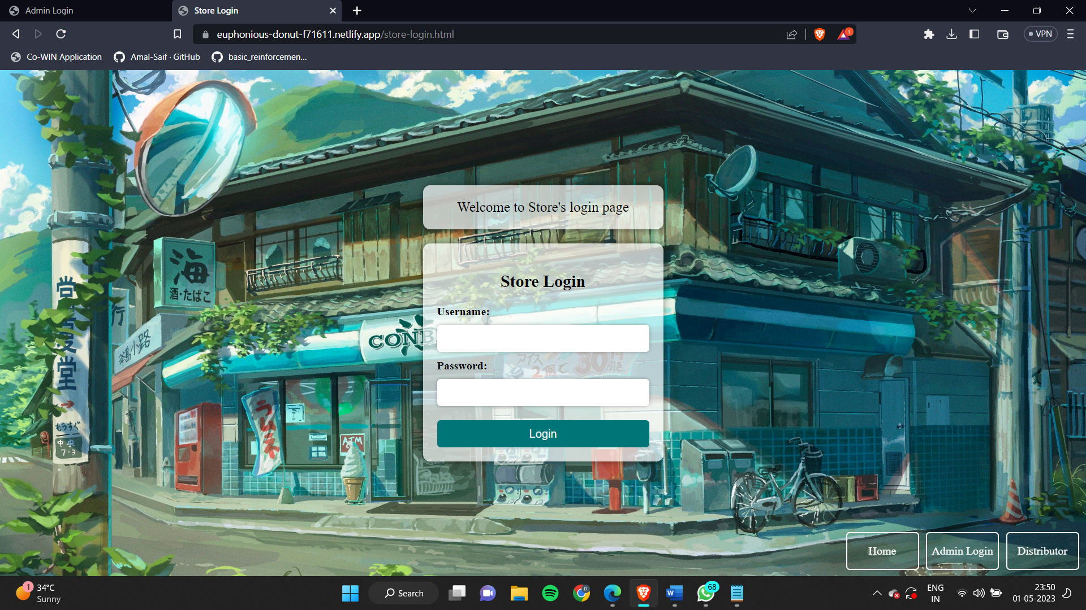

**DISTRIBUTOR LOGIN PAGE:**

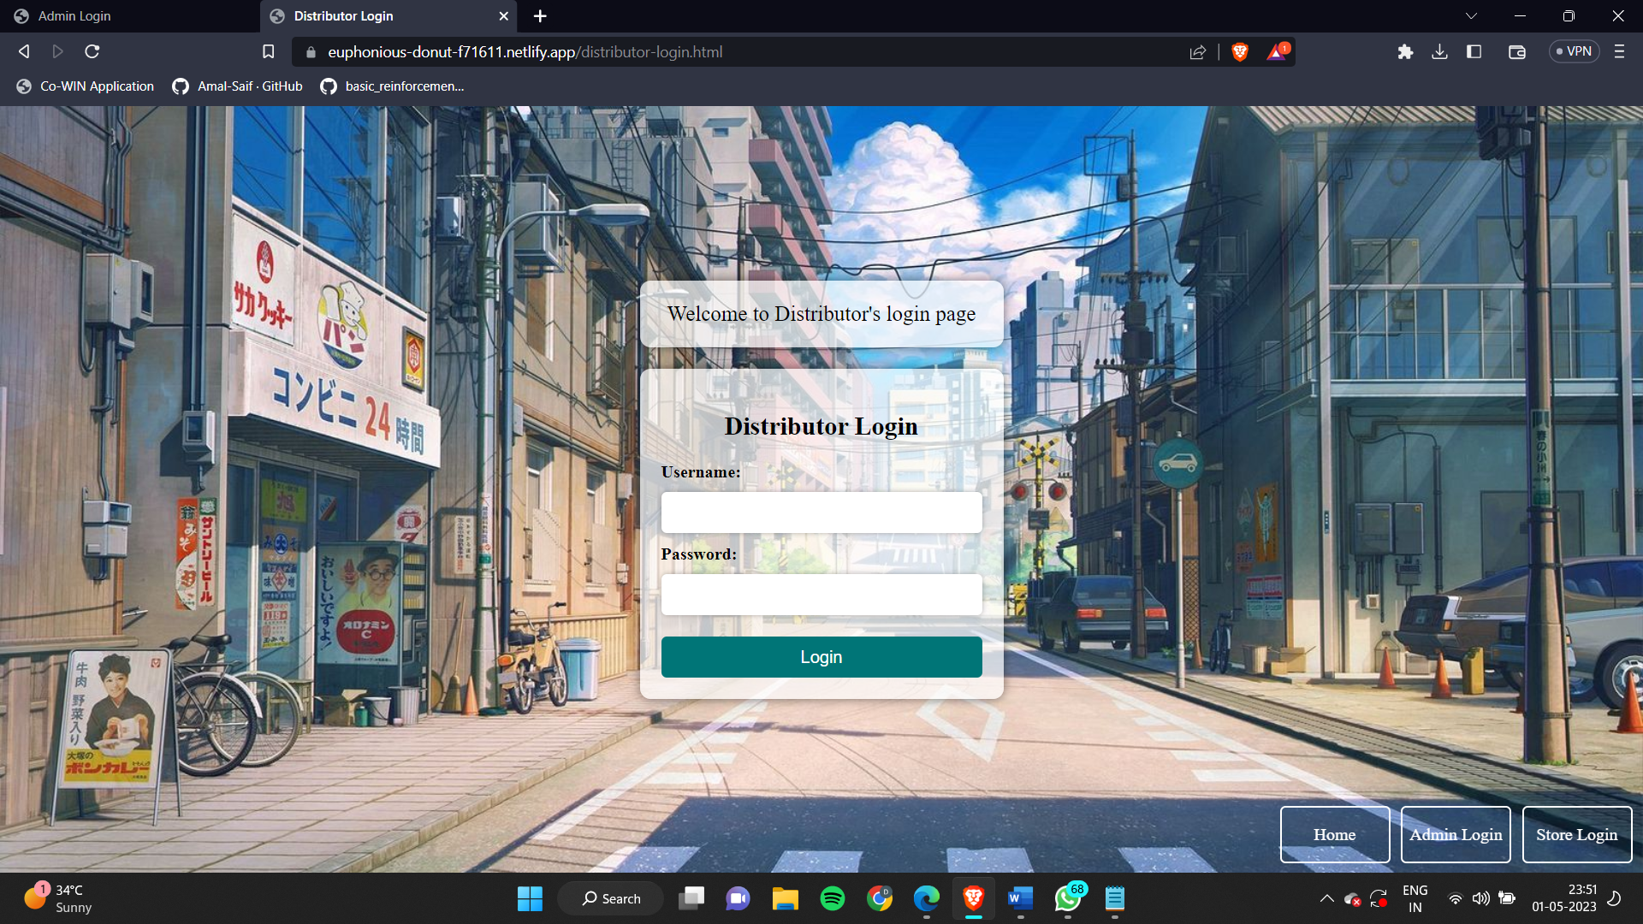

**9.** **Conclusion and Future Work**

**9.1 Conclusion**

In conclusion, a hypermarket sales database system is an essential tool for managing sales operations in a hypermarket. Such a system can help hypermarkets to effectively manage their sales and inventory, and make data-driven decisions to improve profitability and customer satisfaction.

a hypermarket sales database system can provide numerous benefits to hypermarkets, making it a valuable investment for any hypermarket looking to improve their sales operations and stay competitive in today's retail landscape.

….

**9.2 Scope for future work**

There are several areas of future work that can be explored in a hypermarket sales database system:

Incorporating Artificial Intelligence (AI) and Machine Learning (ML) technologies: By incorporating AI and ML algorithms into the system, it can help to automate processes such as inventory management, demand forecasting, and personalized marketing, thus increasing efficiency and accuracy.

Implementing Real-time data analysis: By implementing real-time data analysis tools, the system can provide immediate insights into sales trends, customer behavior, and inventory levels, enabling hypermarkets to make quick and informed decisions.

Enhancing security measures: Hypermarkets deal with sensitive customer and financial data, and hence it is critical to maintain robust security measures to prevent data breaches. The future work can focus on implementing advanced security features such as multi-factor authentication, encryption, and data backup and recovery solutions.

Developing a mobile application: A mobile application can be developed for the hypermarket sales database system to enable users to access real-time sales and inventory data on-the-go, thus increasing flexibility and mobility.

Integration with third-party applications: Integrating the sales database system with third-party applications such as social media, email marketing, and analytics tools can help hypermarkets to extend their reach, improve customer engagement, and increase revenue.

In conclusion, by exploring these areas of future work, hypermarkets can enhance the functionality and capabilities of their sales database systems, thus achieving better results, improved efficiency, and greater customer satisfaction.

**….**

**9.3 Roles and Responsibilities**

1. M. Prashanth Choudary : ER Model, Triggers and Queries

2. Vinayak Santhosh Kumar : Introduction, Abstract, Data Dictionary, Create Table (Constraints)

3. Anirudh Derangula : Schema Diagram, Relational Schema and Stored Procedures

4. Dishita Mohan: Compilation of everything

5. Suzen Firasta : Create Table, Insert Commands and Front End